Assignment Format

**Contents**

Both your homework and lab exercise for each chapter should be combined into one document. Your homework should be first, followed by the lab exercise. Do not combine work from multiple chapters into a single file.

**File Name**

The file name for your document must be in the format of "**SNNYournameChapMM.doc**", where:

* **NN** is the two digit number in your database login name. If you number is less then ten then be sure to include the zero (e.g. nine should be "09"). If you do not format this part right your assignment will not be returned.
* **Yourname** is your first and last name, without spaces and the first letter of each name capitalized (e.g. S04JimShoeLab03.doc).
* **Assign** is the type of assignment, either Lab or Proj.
* **MM** is the assignment number that you are turning in. Remember that both the homework and lab go in one file, and the homework should be first. Also, there is no assignment for chapter #1.

**Heading**

Using MS Word's heading feature, change the following in the document header:

* Your name. Use your "preferred" first name followed by last name.
* Chapter number
* Course Number
* Semester

**Screenshots**

For each homework problem you must include a screenshot. For most chapters there are two separate homework problems, each will need it's own screenshot. Each lab exercise will ask for one or more screenshots.

Each screen shot will have it's own page in the document. For each of screen shot you must fill out the following sections:

* **Title** - this is the table cell at the top of the page. For the homework copy and paste the assignment section and page number (e.g. "Section 3-7, page 105") For lab exercises copy the first line of text to the right of the camera icon.
* **Screenshot** - Use "alt-print screen" to copy the entire SQL Developer applications as a screenshots. Copy this into the large table cell. Your screen shot must be readable. See more details below.
* **SQL Code** - copy and paste your actual SQL text into the table cell in the lower left corner. This should be in the "Courier New" and 6 point font (it's already set to this, so just make sure you don't change it).

The table cell in the lower right is where I will put your grade and any comments I have for you. Do not put anything here.

Each screenshot must show the entire query and results. If this won't fit on one page then use two pages, and number the title. For example, add the text "(1 or 2)" to the title.

**Example**

Click the image to see it full size.

[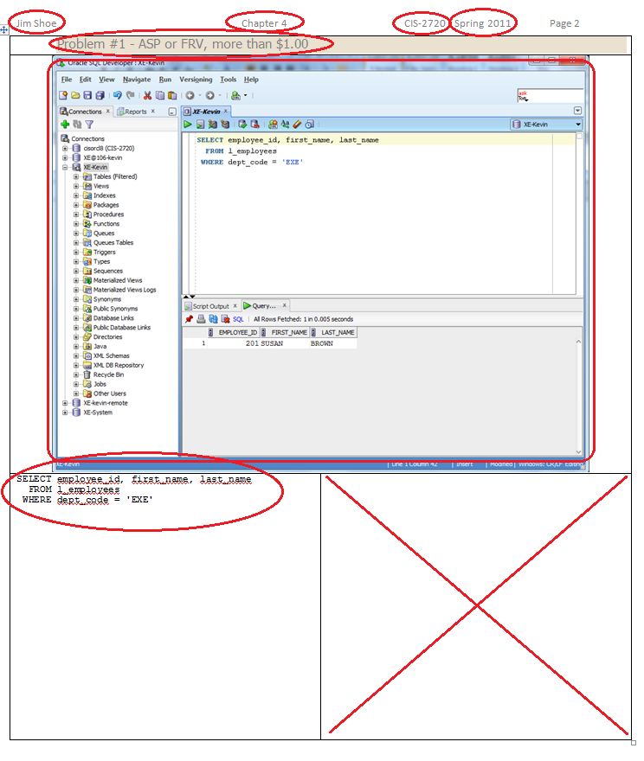](http://www.thatlink.com/Classes/Main/DisplayImage.aspx?Section=cis2720sp14&File=AssignmentFormat02.png)

**Aspect Ratio**

Your screenshots must be in roughly a 4:3 aspect ratio. Aspect ratio is the relative width of your screen shot compared to the height. The 4:3 ratio is the ratio used by old TVs and computer monitors. New HDTVs use a wider 16:9 aspect ratio. See the examples below:

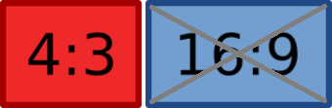

The following is an 16:9 screenshot. It is example of **what not to do**. Note the wasted space on the right part of the screen. This space is not used because you should not have more than 80 characters on single line.

When pasted into a word document, the wider screen shots make the font size shrink so that it is unreadable.

[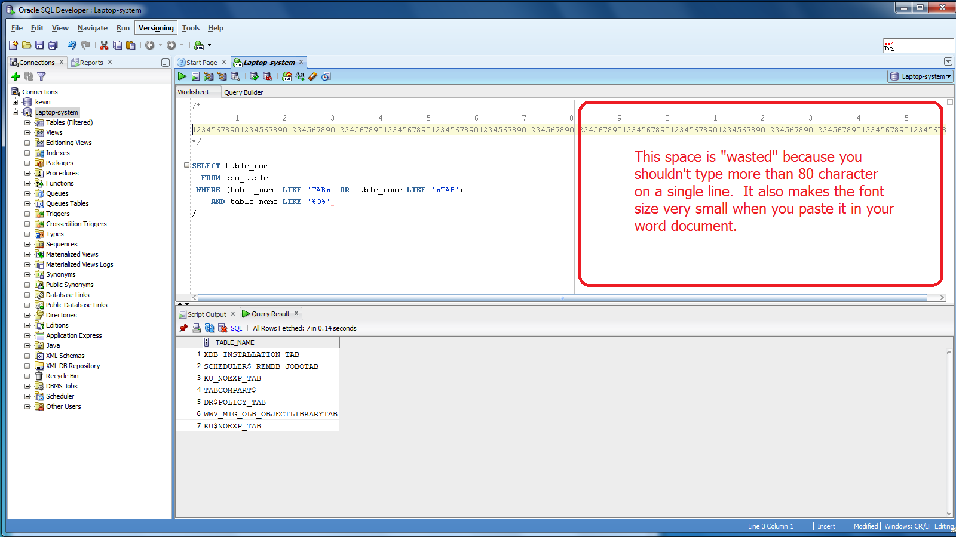](http://www.thatlink.com/Classes/Main/DisplayImage.aspx?Section=cis2720sp14&File=AspectRatiosSS16x9.png)

Before taking a screen shot resize you window so that it is roughly 1024 wide by 768 pixels high. See the example below. Make sure you use alt-print screen and not just print screen when taking your screenshot.

[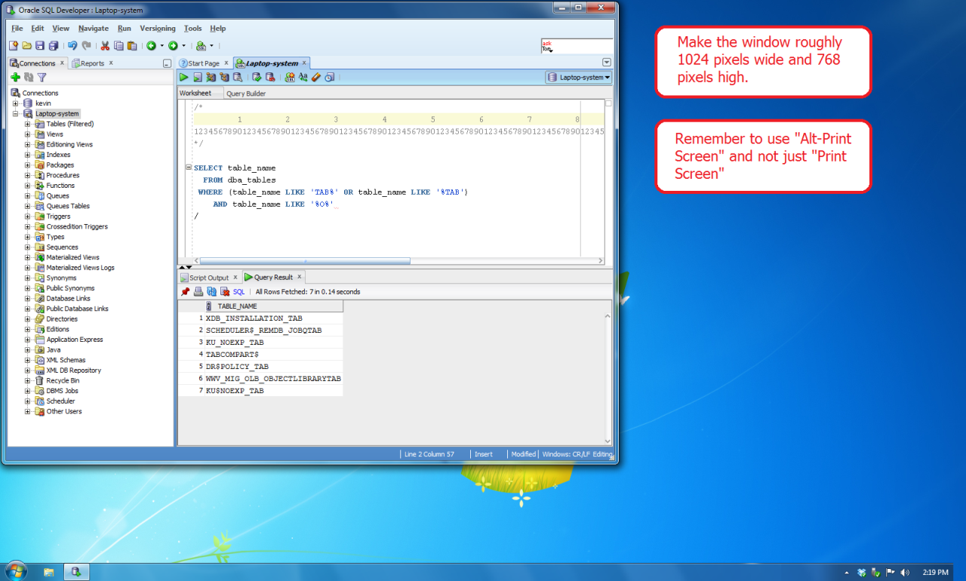](http://www.thatlink.com/Classes/Main/DisplayImage.aspx?Section=cis2720sp14&File=AspectRatiosSS4x3.png)

**Highlighting Code**

Do not highlight a section of text in a longer script. Show only the code that you are running in your screenshot. Remove other code and non-relevant comments. The following is an example of **what not to do**.

[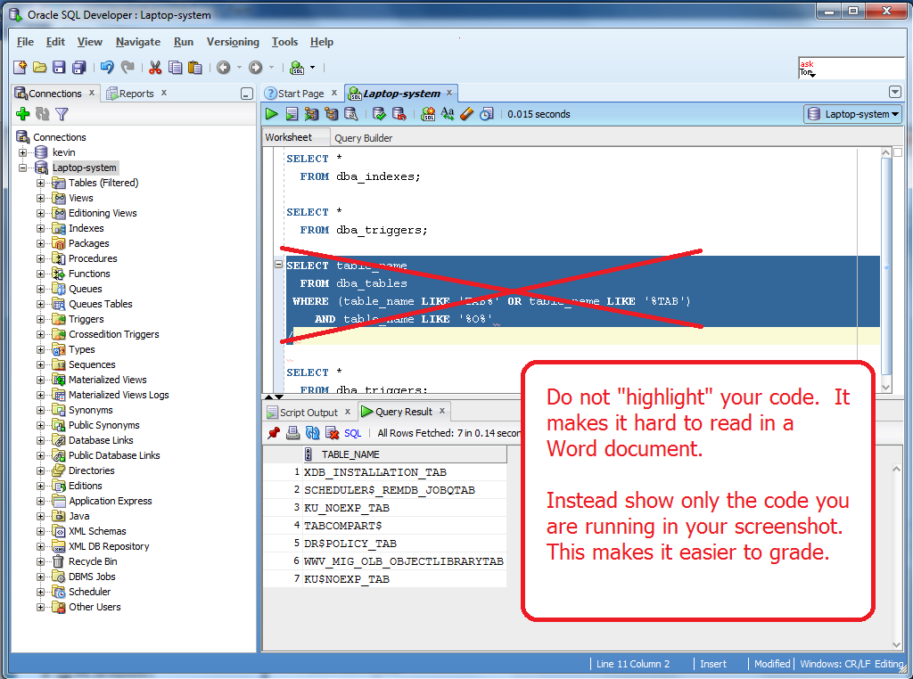](http://www.thatlink.com/Classes/Main/DisplayImage.aspx?Section=cis2720sp14&File=SSHightlighting.png)